UI Design and Prototyping Report Template

**Sports Hub**

1. Introduction

A Sports Hub that provides and manages various activities such as member registration, registration for various regular and vacation batches and more. The sports system that manages the entire club activities and provides respective 9 functionality for various types of visitors. This system is built with respect to managing both indoor and outdoor sports. It allows normal users to avail for hub membership, book the ground at for desired days and even enroll for various activities in the hub. It will help the tenant with making Payments and owner to keep track of issues posted by tenants.

In the current sports system, all the work is done manually. Admin keeps

the track of all the work going on and maintains a receipt of payment which

is generated manually. Admin and employees are facing issues while

maintaining data which is very time consuming in fetching the data. Storing

in the proper format and Space complexity has been a major issue.

This application gives the user all the details of different varieties of sports and allows the user to book a slot at the arena to play his/her chosen sport. The information system meets user needs by accomplishing the following.

• Performs the right procedure properly.

• Presents information and instructions in an acceptable and effective fashion.

• Produce accurate results.

• Provide an acceptable interface and method of interaction.

• Perceived by users as a reliable system

1. User Interface Design and Prototype

Register User



Login User



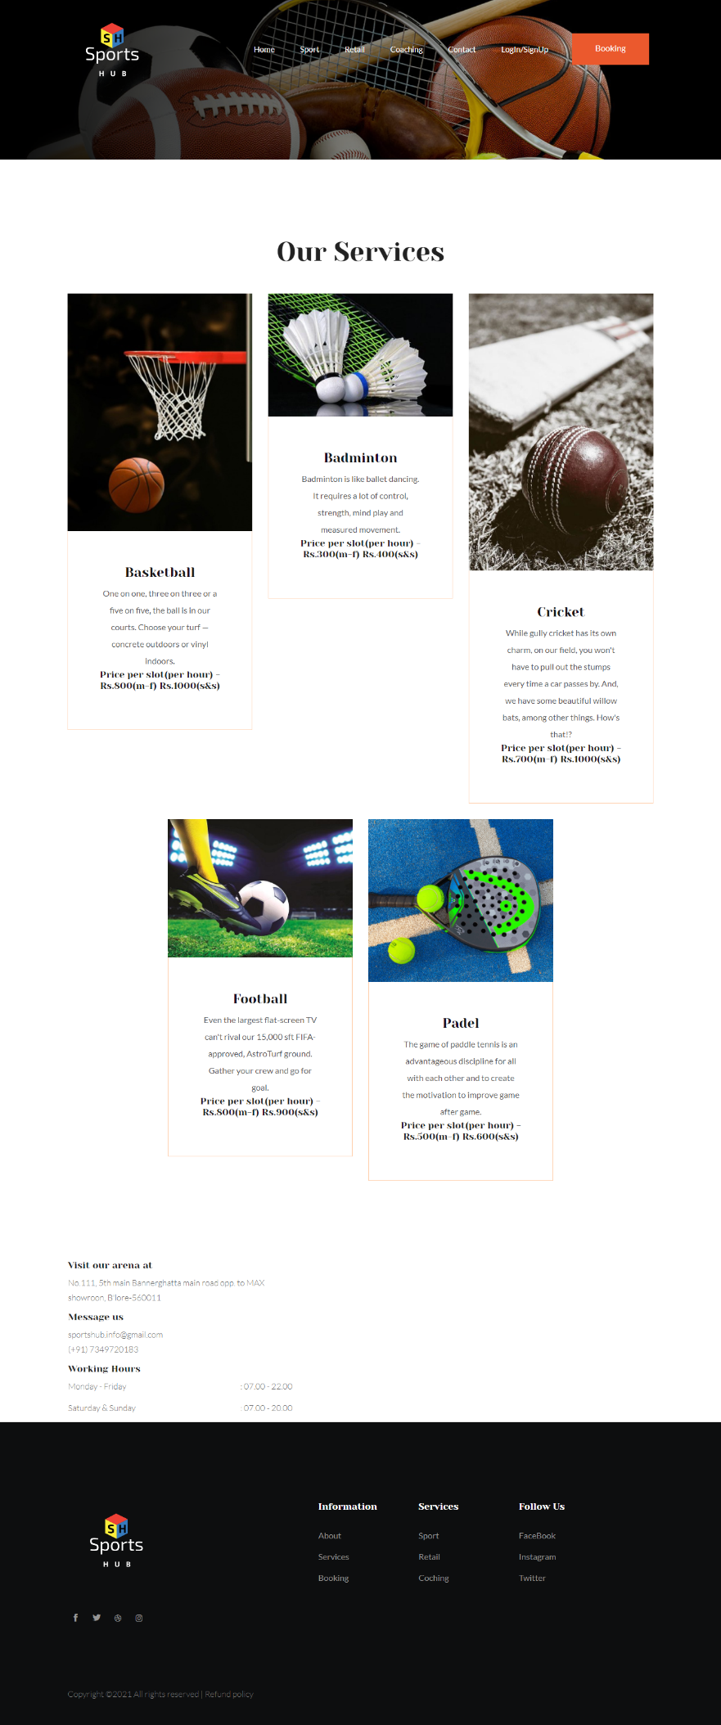Sports Category page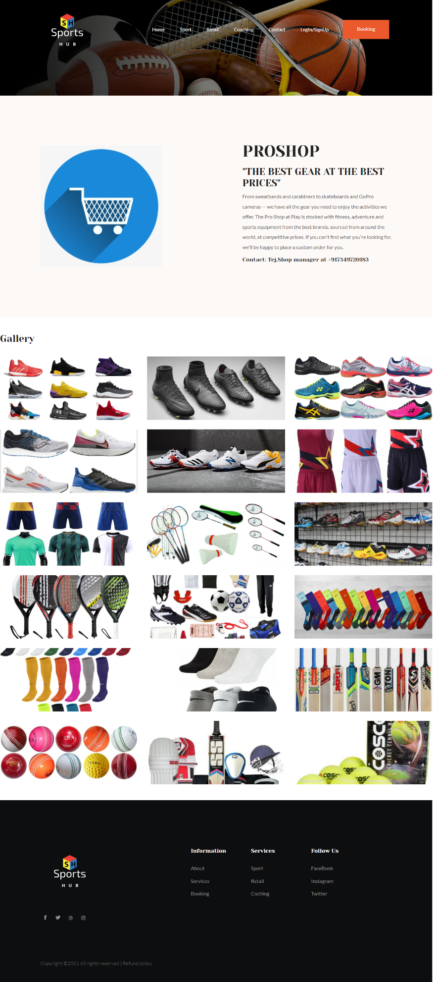Retail page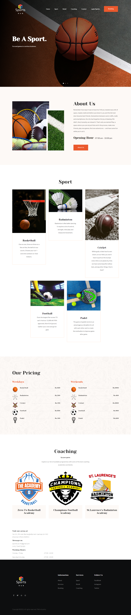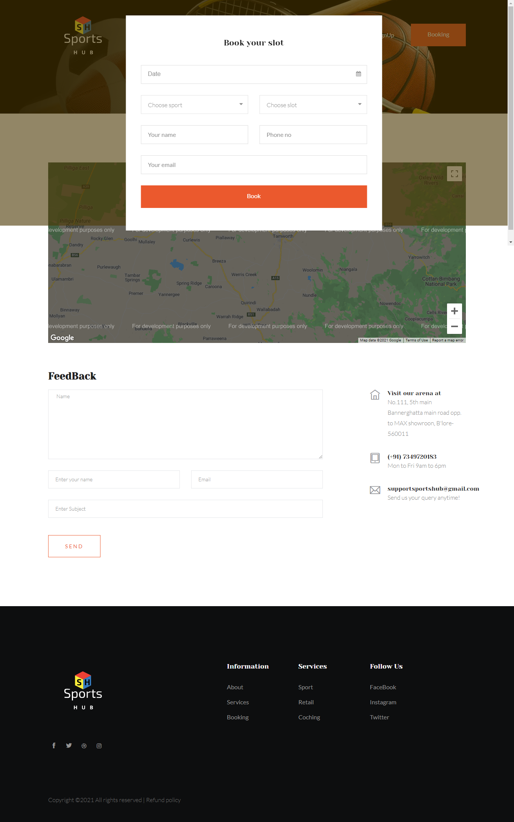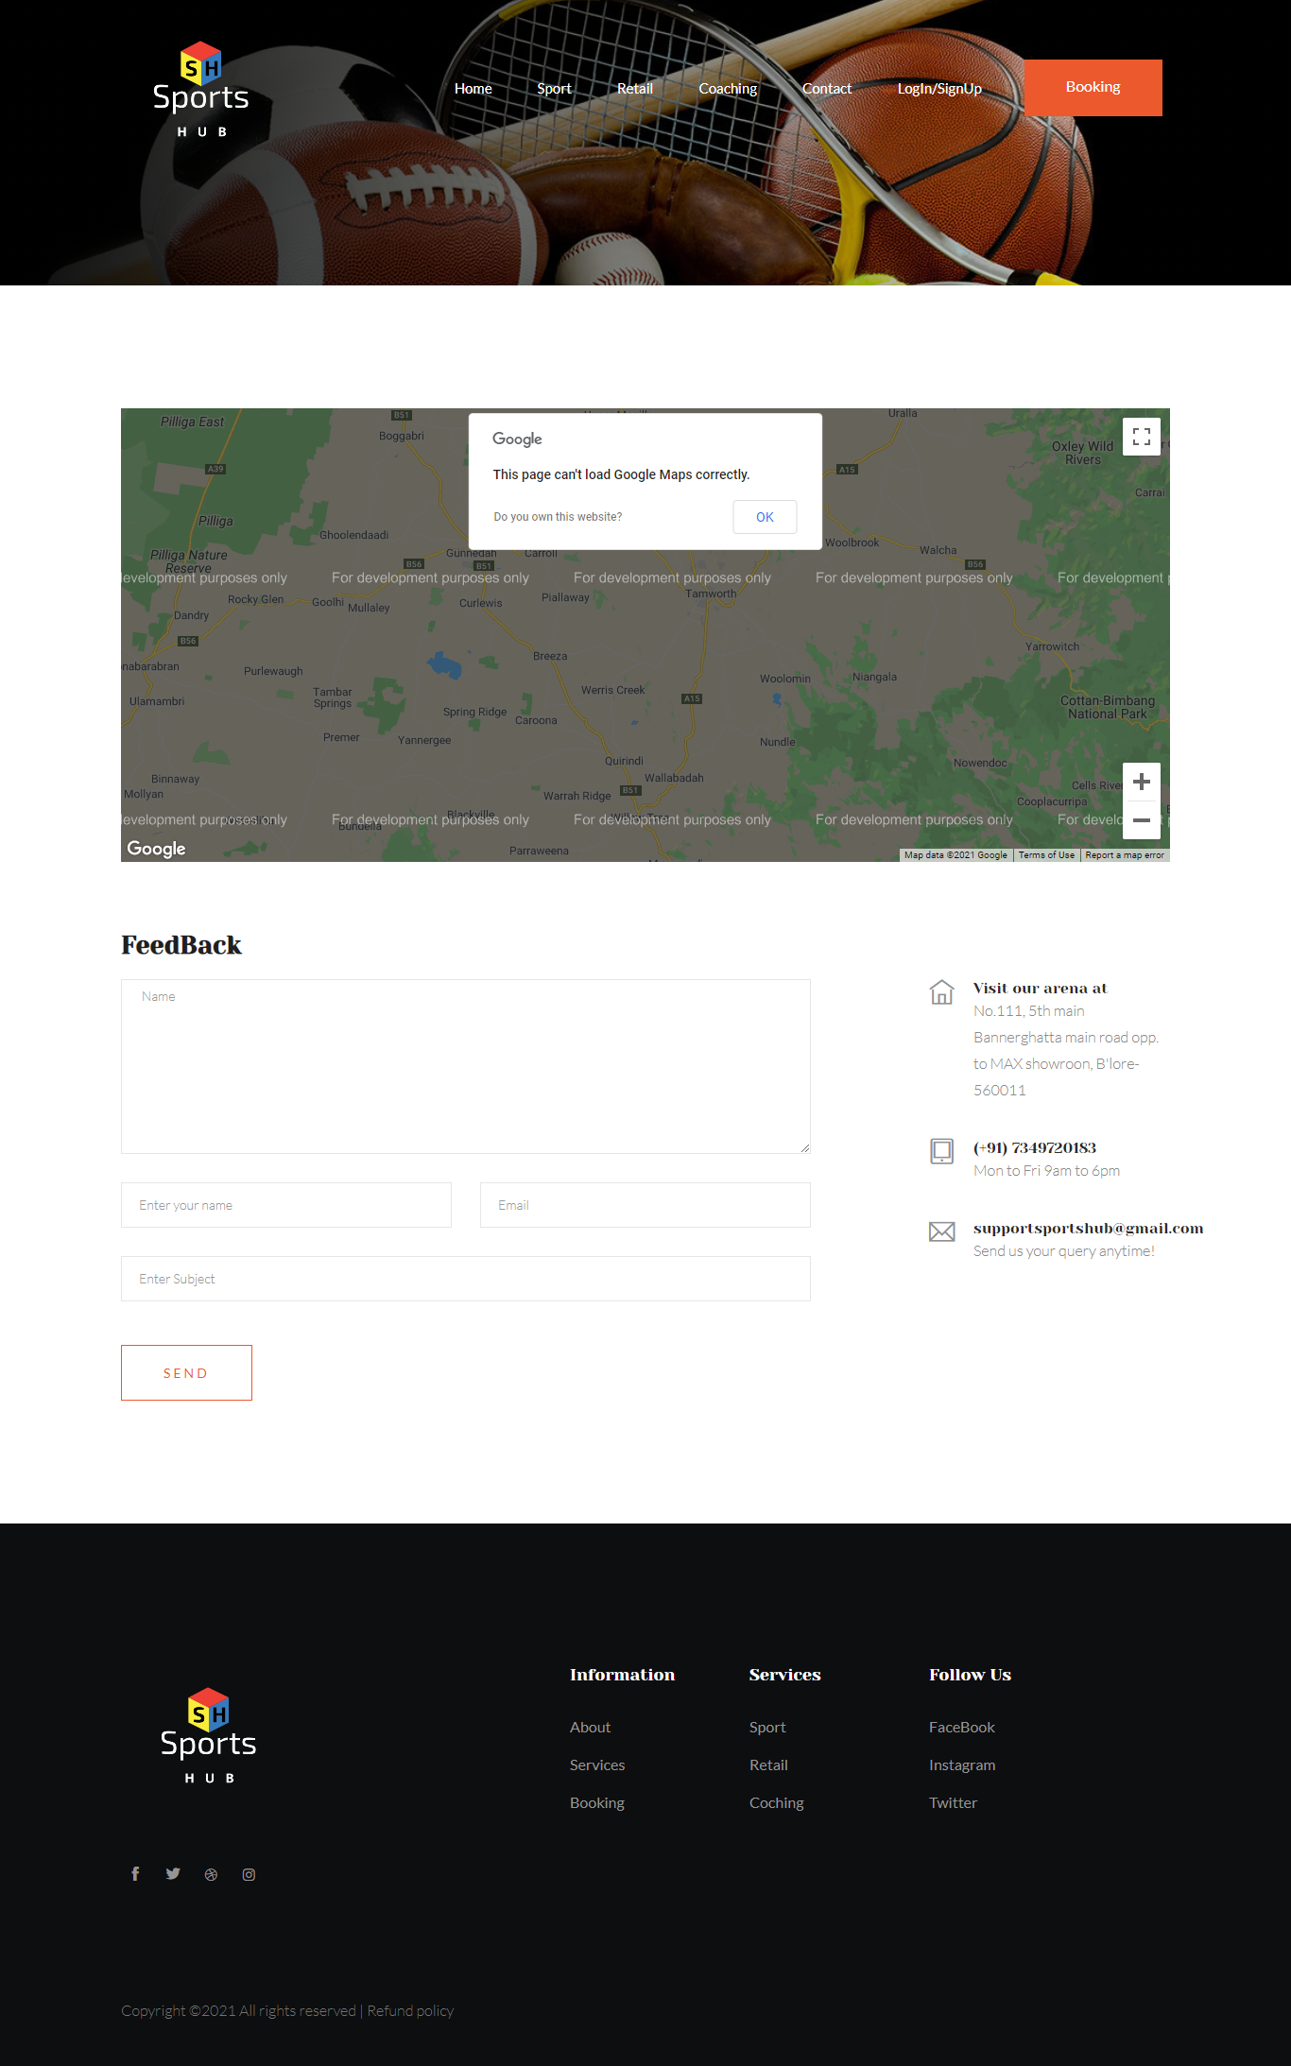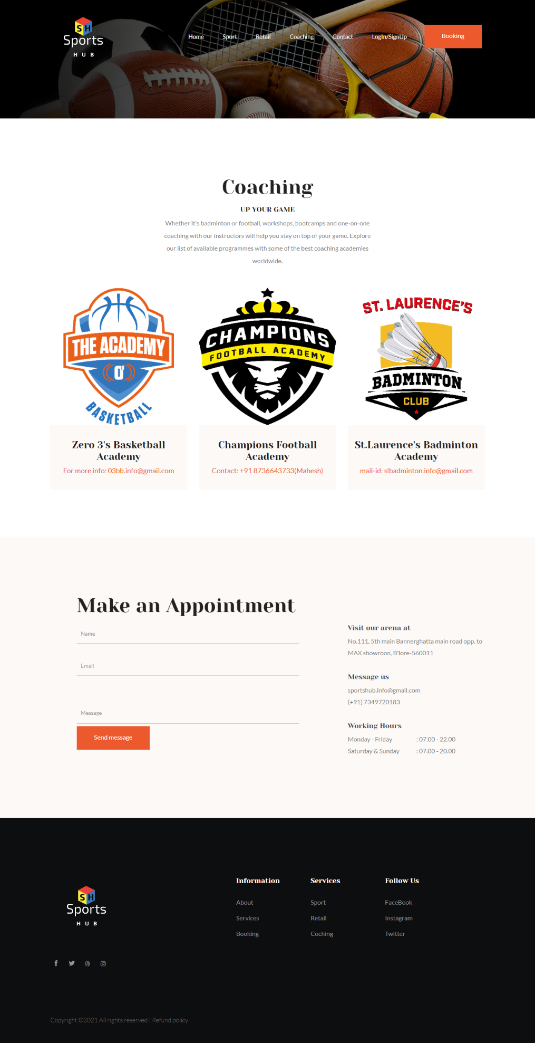

1. Navigation Structure

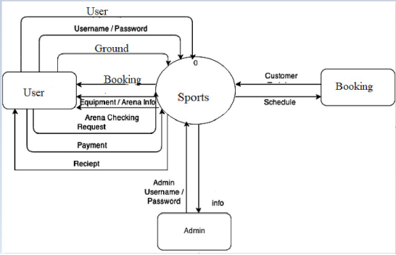

Website flow diagram

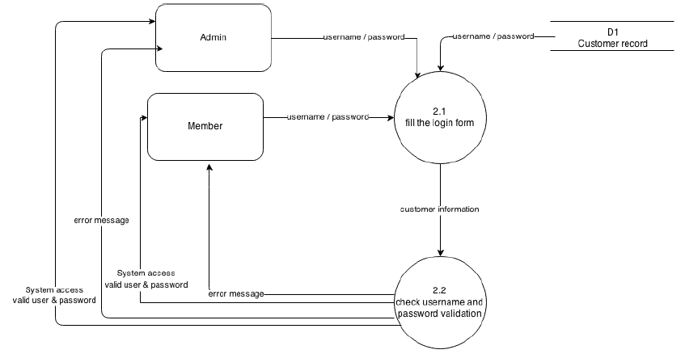

Login flow diagram